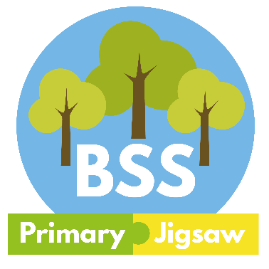
The Day We Went Back To School

By Wendy Smith
Illustrations by Jessye Gardner

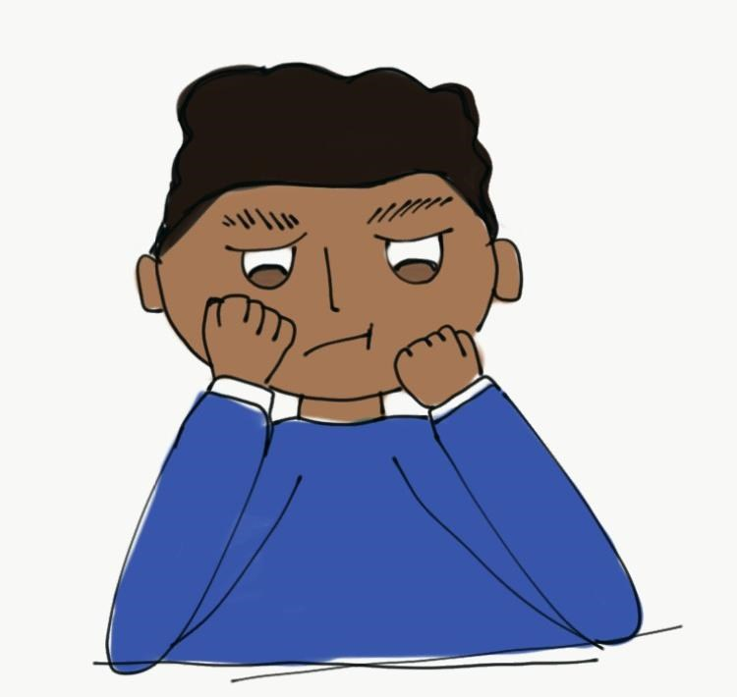

It was Monday morning and Zayn was looking out of his bedroom window and watching lots of children walk down the road, all heading to Zayn’s school and all looking happy and confident. Zayn scowled down at them and thought, “What have they all got to be so happy about?”

“It’s nearly time to go Zayn, put your shoes and coat on please.”

Zayn heard his Mum calling up the stairs but he did not feel like putting on his shoes and coat, he felt like hiding under his duvet and staying there all day. He kicked his wardrobe door and flopped down on his bed.

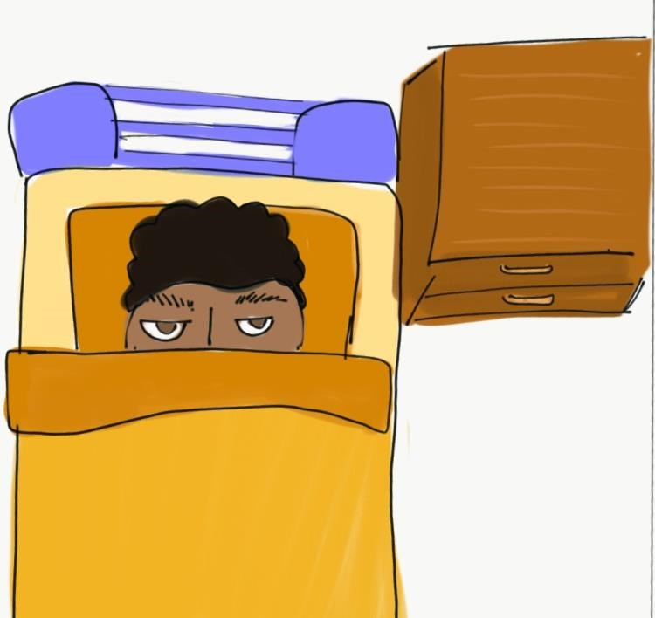

Lockdown was over, schools were open, Mum could go back to work and apparently everyone was supposed to be all happy about this.

His big brother and sister had already left for their school with smiles all over their faces. His brother had been talking non-stop about seeing all his friends again and his sister was going on about how bored she’d been in lockdown and how she couldn’t wait to start doing her lessons again.

Even Mum was all excited about going back to work but Zayn just wasn’t feeling the same.

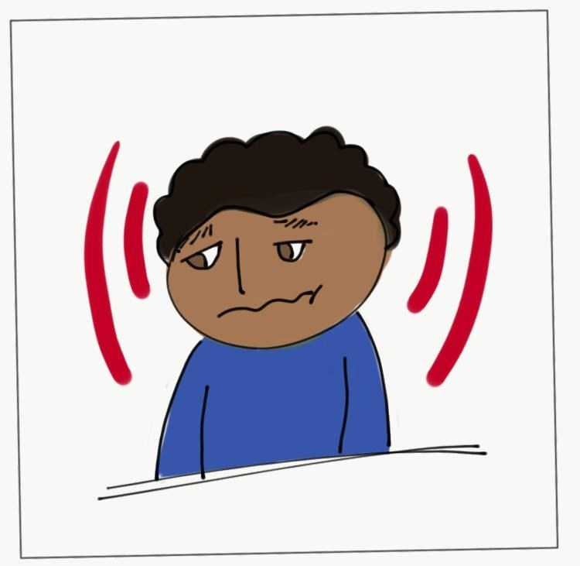
In fact, Zayn was feeling like a shivering, quivering jelly and he just wanted to stay at home where it was cosy, safe and he knew just what was going to happen.

He didn’t really care if it was a bit lonely without his friends and a bit boring without school and Cubs and swimming and football club.

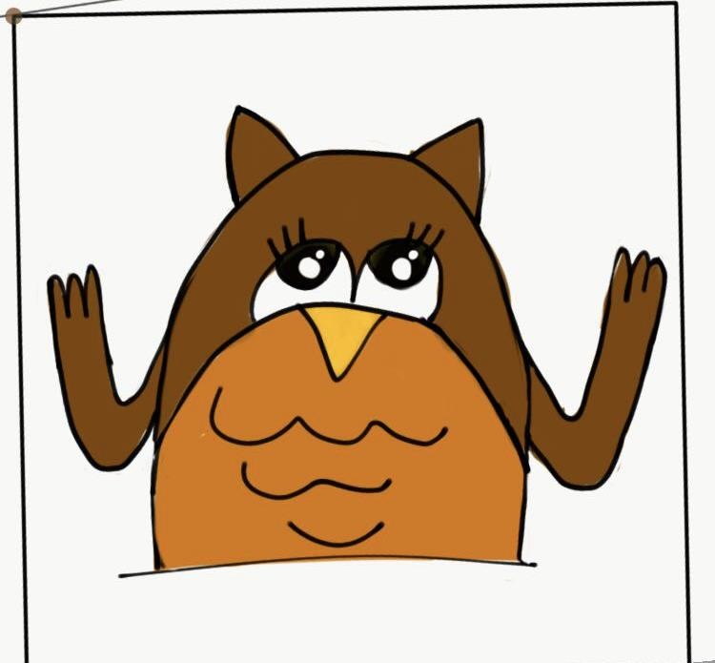
Zayn was just wondering what he should do next, when he heard a tap at the window and looked up to see his friend, Olivia Owl.

She was a very wise old bird who knew practically everything there is to know about everything and she always seemed to be around when Zayn needed some help.

Zayn opened the window and stroked Olivia’s soft feathers and before he knew it, he was explaining to Olivia just how he felt. Telling her how today he was like a quivering jelly who needed to hide away at home and how he felt as if he couldn’t even tell his Mum about this because everyone else was being so happy.

Olivia Owl listened carefully and nodded wisely and said, “I think it is very normal to feel a like a jelly today. We are all going through a very big change and that makes most people feel wobbly.”

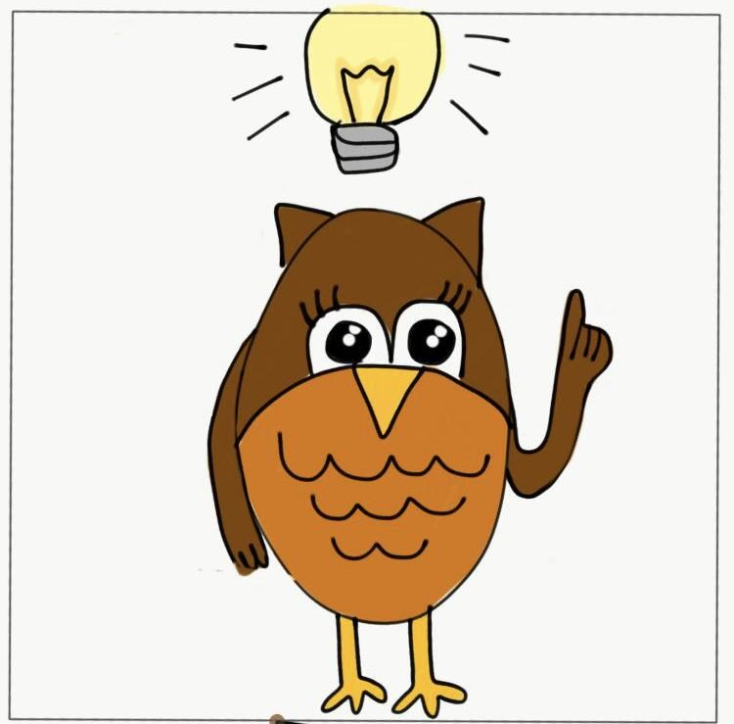

Zayn shook his head and stared at his socks miserably, “No, it’s just me that’s a jelly today everyone else is smiling and looking confident. I bet they’d all think I was a wimp if they knew.”

Olivia stroked Zayn’s cheek with her soft wing and said, “I promise, it’s not just you. A lot of people are putting on brave smiling faces but inside they are all a bit wobbly as well. Would you like to borrow my magic glasses and see if I am right?”

Zayn nodded enthusiastically, he loved it when he could use Olivia’s magic glasses. When he was wearing them, Zayn could see what was going on inside people. He could see their thoughts and feelings as well as what was happening on the outside.

With the glasses in position Zayn looked down at the road. He saw Seth and Suzy walking together and they were chatting away as if they hadn’t a care in the world. But inside Zayn could see that they were both feeling scared.

Seth was scared about leaving home, he hadn’t been out of his garden for weeks so going out into the big wide World felt very scary.

Suzy was scared about not being with her Mum and Dad, she’d loved being with them all day during lockdown and now it was scary being without them.

Zayn could see that both children had quivery jelly parts inside.

Next Zayn saw Edgar running along the road as if he was in a sprint race and just behind him was Ellie zipping along on her scooter. Zayn trained his glasses on the two children and saw that they were both brimming over with excitement.

Edgar was really looking forward to seeing his teacher again and he couldn’t wait to have lots of children to play with at break time.

Ellie was so excited about seeing all her friends again and doing her favourite lessons, she was hoping Miss Brown would do maths, history and art today.

Zayn scowled at the two excited children but then he felt Olivia’s wing giving him a little nudge and she said, “Look very carefully.” He peered at Edgar and Ellie through the magic glasses and saw that although they were very excited, each did have a little wobbly part, a little quivering jelly part inside.

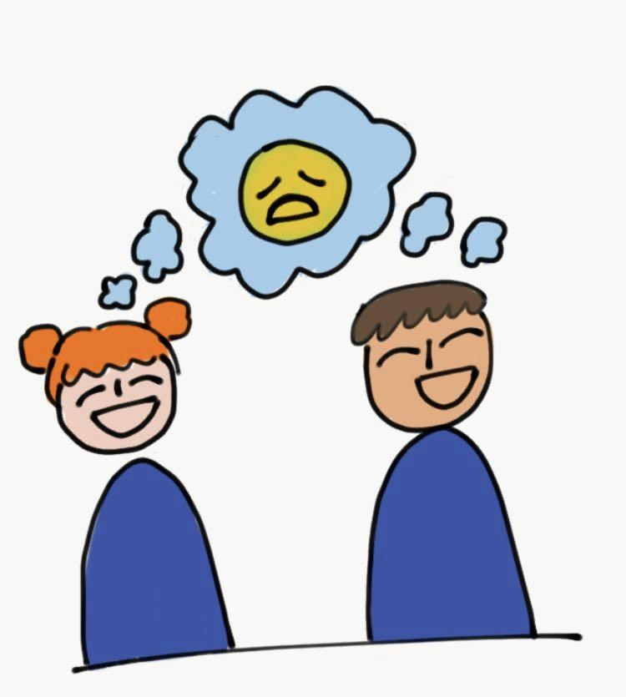

A loud crash made Zayn turn his attention away from Edgar and Ellie and onto Adam and Ayesha, who were the next children making their way to school. Adam had just swung his bag into the garden fence he was passing and Ayesha looked as if she was muttering to herself. Zayn’s glasses showed him that these were two children who were feeling angry.

“It’s just not fair,” thought Adam, “My Stepdad and me were halfway through building my den. It’s brilliant and we were going to paint it today and now I’ve got to wait until the weekend just because they’ve opened stupid school.”

“Why do they keep changing things,” thought Ayesha, “First they tell me that I can’t go to school and I can’t go to Brownies and I can’t visit Nana. It’s horrible but I’ve just got used to it all and now they want me to change everything again. I just wish they’d stop messing me about.”

And sure enough hiding behind the anger inside Adam and Ayeshsa were two quivering, shivering jellies.”

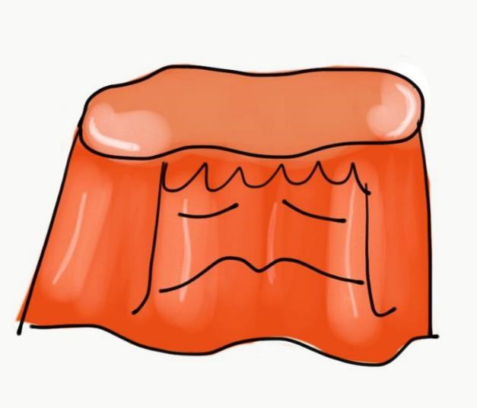
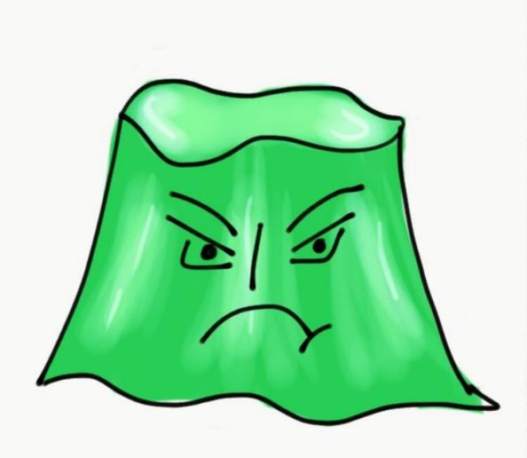
Some cheerful singing drew Zayn’s attention to Harrison and Hardeep. He could see that they were both feeling happy about returning to school but he decided to take a very careful look and he spotted two little quivering jellies. They were happy but both children were also feeling just a little bit wobbly as well.

A car went past and in the back seat, Zayn saw William and Wanda and Zayn’s glasses showed him that they were both very worried. William was thinking, “I don’t know if I can remember anything about school, what if I don’t know what to do or I can’t remember where anything is?”

Wanda bit her nails as she thought, “What if I can’t do the work? What if I’m behind all the other children? I think I’ve forgotten all my times tables.”

Zayn took off the magic glasses and said, “You see Olivia, I think I am having all those feelings.”

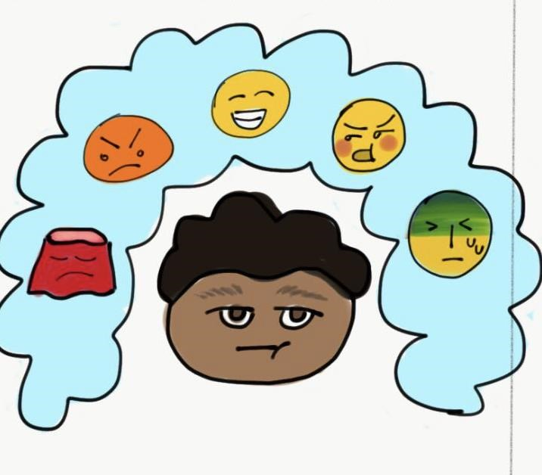
“I am kind of happy and excited to be going back because I know there will be lots of good things happening and I have been a bit bored at home.

But I am also scared and I can’t even really decide what is scaring me but it just all feels very frightening.”

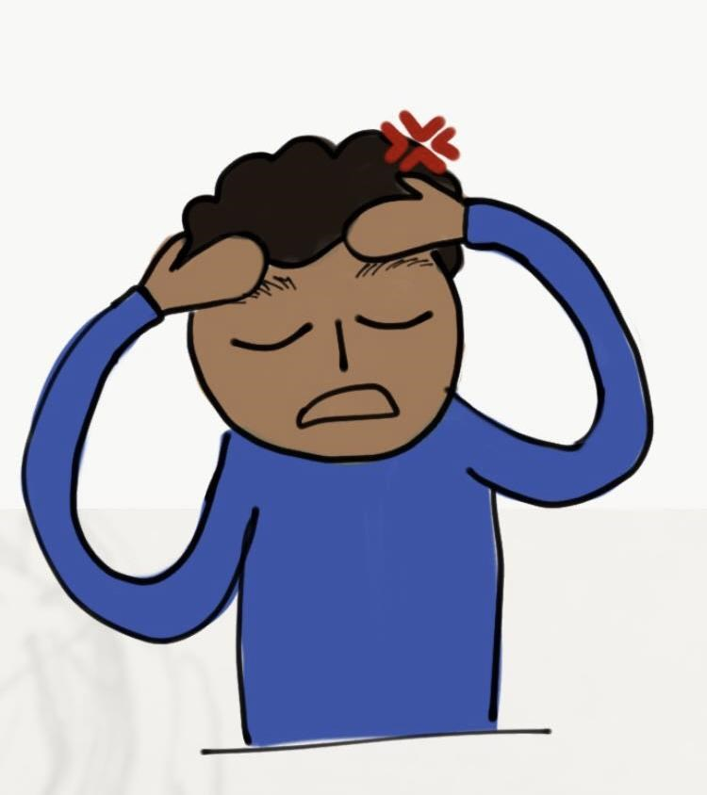

“I have got lots of worries, like….
What if the teacher is cross that I haven’t done all the lockdown work that she set?

What if it feels really weird being with my friends again and I don’t know what to say to them?

What if I’ve forgotten all the stuff that I’d learnt before?

I am angry. I’m angry about all the horrible stuff that I’ve seen on the news, I’m angry that they shut the swimming pool and I’m angry that I’ve got to go back to school.”

Zayn said, “I’ve got happy, excited, scared, worried, angry, this quivering jelly feeling and probably some other feelings that I haven’t even noticed yet and they’re all going round and round inside me.”

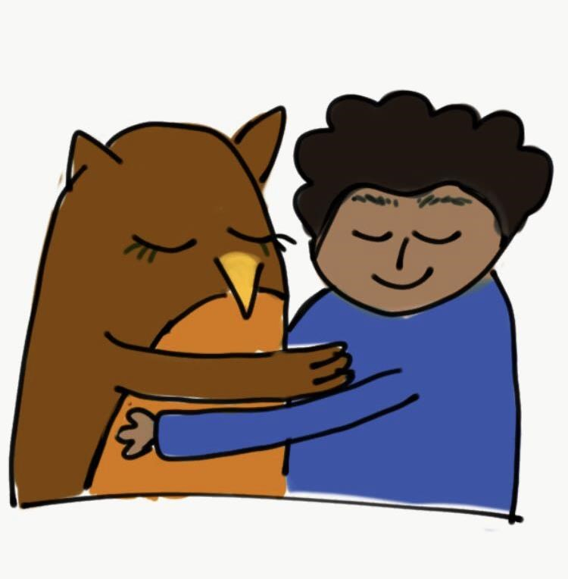

Olivia nodded sympathetically, “That sounds very difficult and I am here to help.” For a little while Olivia just wrapped a comforting wing around Zayn and gave him a hug.

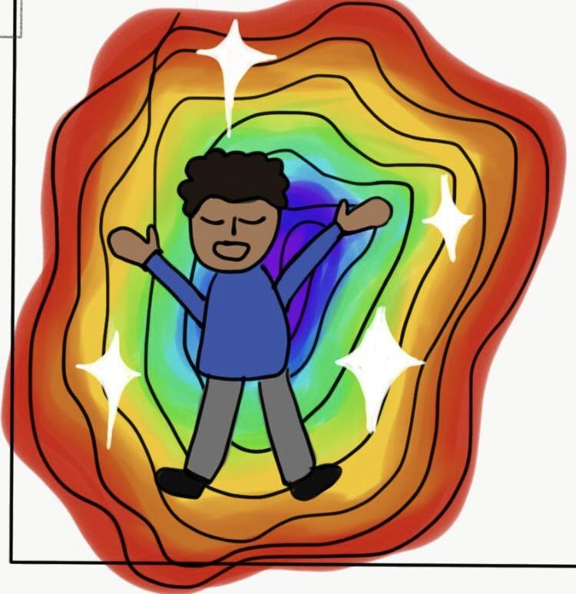

Then Zayn sat up and Olivia said "Let’s start by taking some calming breaths.”

Zayn felt himself becoming a little calmer as he breathed as Olivia said, “Breathe in through your nose for 3, hold your breath for 3 and breathe out through your mouth for 3.” After 5 deep breaths Zayn was feeling a little better.

Olivia said, “Next let’s remind ourselves about the people who are going to be around to help you and keep you safe.”

Zayn thought for a moment and said, “There’s my teacher Mrs. Davison, Mr.
Jones who helps in our class, the Dinner Ladies and Miss Young the Headteacher. Well, all the teachers and grown-ups in school really, some of them are a bit bossy but they do all care about us and look after us.”
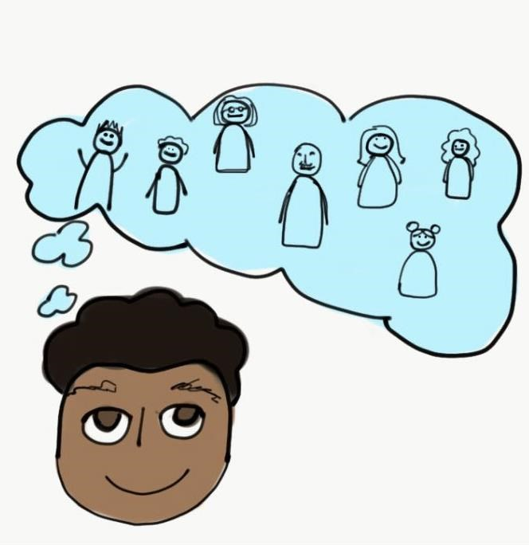

“That’s great,” said Olivia, “Can you think of anyone else?”

“My friends,” replied Zayn, “They help me out. I know Mum will be at work but if I needed her, Mrs. Davison would call her and she’d come and my Nana lives near school and she’d always come to look after me.”

“So there are going to be lots of people around you who care about you and who will look after you and keep you safe.” Said Olivia. Zayn nodded and realised that he was feeling a little bit better.

Olivia said, “Today is a big change and a big challenge, have you ever faced anything like that before?”

Zayn was about to say that he hadn’t but then he said, “Well I suppose when I started school in reception that was a big challenge and then when I was in Year 3 we moved house and I came to this school, I was scared then.”

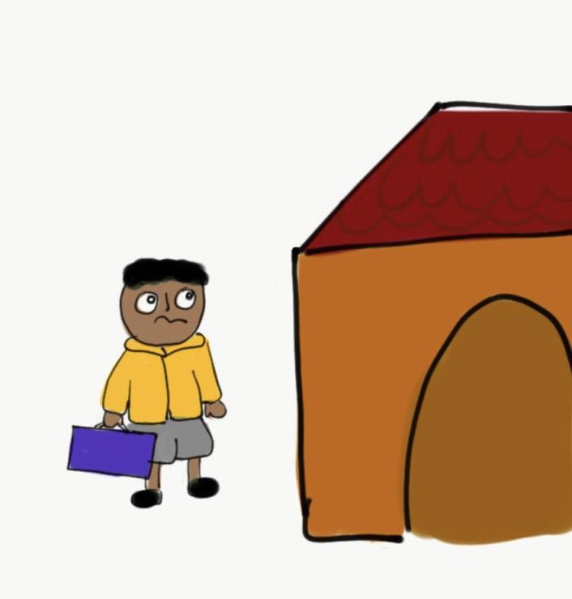

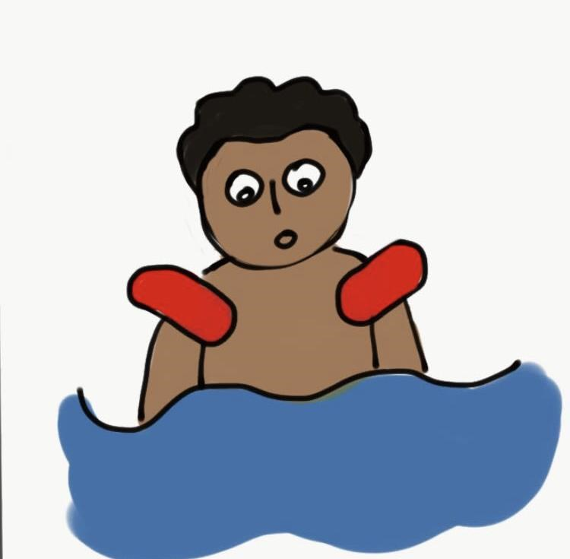
“When I joined the swimming club and when I went in my first swimming tournament I felt like a quivering jelly both
times.”

“My first night at Cubs and when the football coach made me be the goalie in a match, I was worried about both of them.”

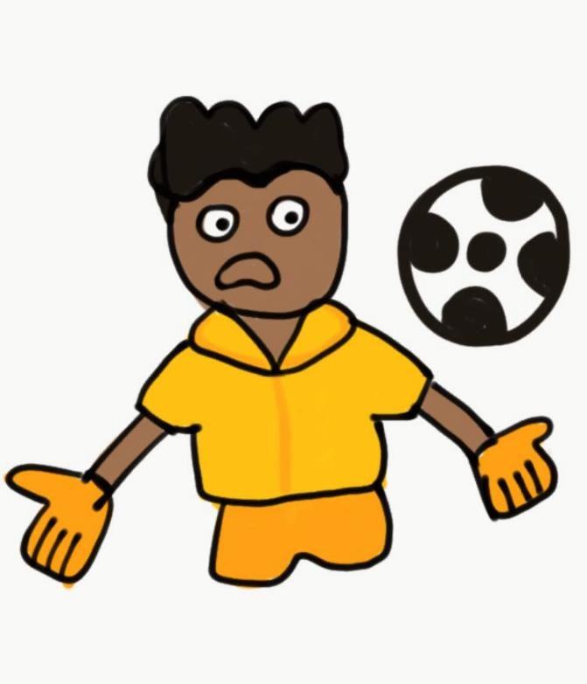

Olivia nodded wisely, “And how did you cope with all those big challenges?”

“I coped O.K.” said Zayn, “They all felt a bit weird and difficult at the start but I did cope with all of them and that made me feel proud and strong.

Most of them turned out to be really good as well. I enjoy school most of the time, Swimming Club is great and I’ve won loads of medals.

I have a good time at Cubs and my Football Club is brilliant, I didn’t really like being the goalie that time but the coach was really proud of me for filling in when Rob, our usual goalie was ill.”

Zayn noticed that again he was feeling a little better. Today was going to be a big change, he was going to feel lots of feelings and half of him still felt like a quivering jelly. But Zayn felt that he was calmer, he knew he was going to be looked after and he’d remembered just how brave and strong he could be.

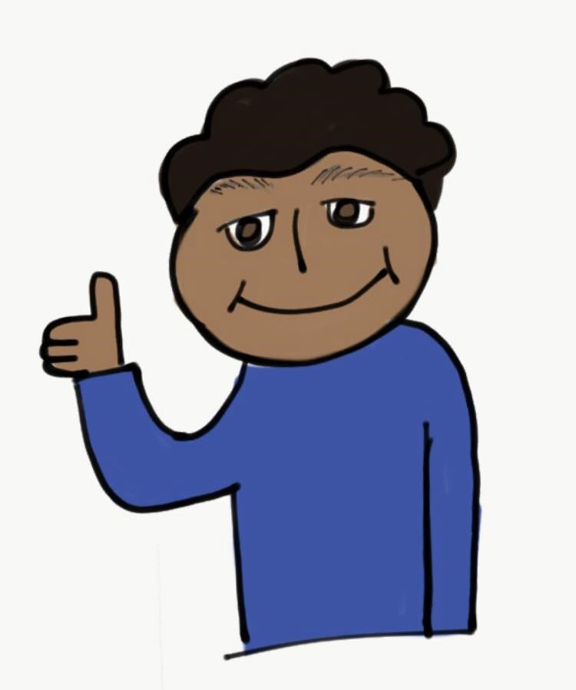

This time when Mum called up the stairs, brave Zayn jumped up and ran down to grab his coat and put on his shoes.
Five days later, on Friday afternoon, Zayn had just got in from school and was sitting on his bed and again heard Olivia tapping on the window.

“Hi Olivia,” said Zayn, “Look, I got this sticker today for good work and I had such a good
time at dinner time, my whole class played a game of rounders.”

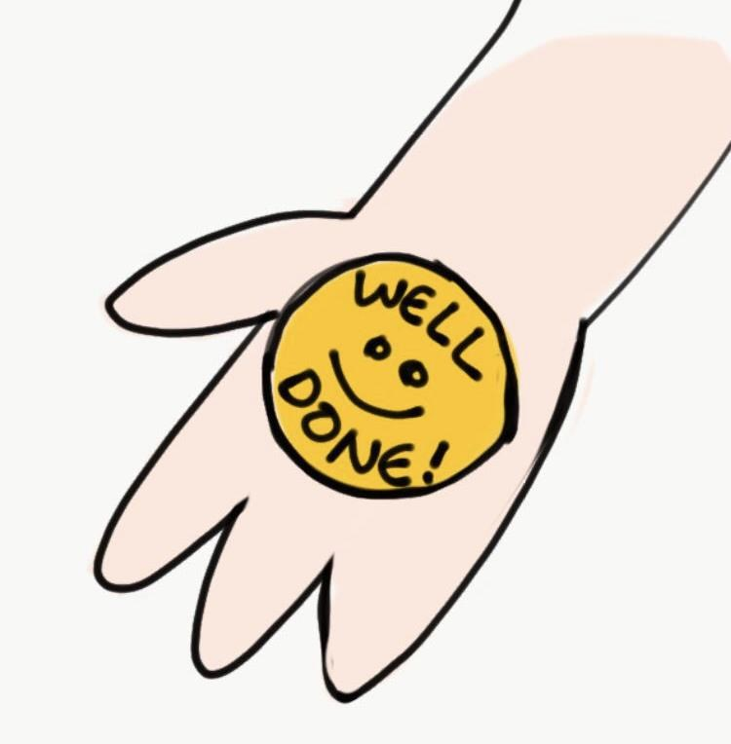
“You sound very happy,” said Olivia, “Does that mean you’ve
had a good week?”

Zayn replied, “Well Monday morning did feel very weird but Mrs. Davison looked after us all. She didn’t say anything about me not doing all the lockdown work and it has been interesting to do lessons again. I was getting bored at home really.

We had all forgotten different bits of work but we’ve all been helping each other and Mrs. Davison is going over things to remind us so that’s fine.

It is great to have lots of children to play with and not just my brother and sister. I did feel a bit awkward seeing some friends again but by Wednesday it felt like we’d never been apart.

Oh and you must fly by the school and look in my classroom window because on Thursday, Freddie and I made a Viking shield and it was brilliant and its up on the wall.”

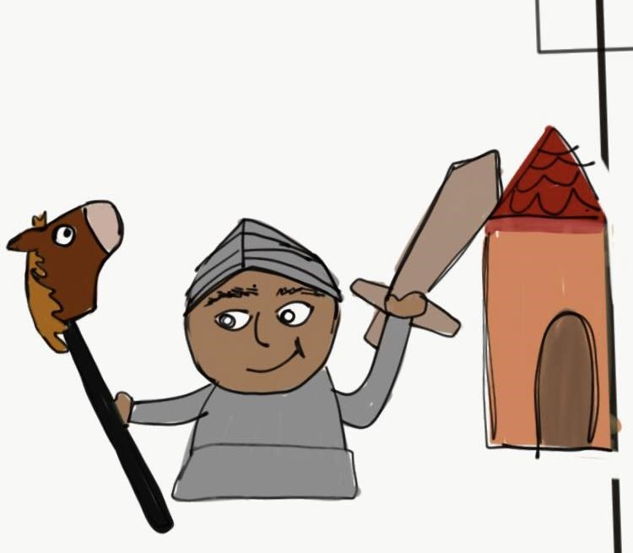

Olivia asked, “So you don’t wish we were still in lockdown, you don’t want to hide under your duvet all day and quiver like a jelly?”

“Are you mad?” asked Zayn, “If I did that I’d miss all the good lessons at school but maybe I’ll just hide when it’s spelling, I don’t like that.

I’d miss Cubs, it was our first week back last night and it was so cool. Swimming Club and Football Club are going to start in a couple of weeks and I can’t wait for that.

So no, I’m definitely not staying in again all day and I’m not hiding under the duvet.

Right, I’ve got to go because I’m going to play at Freddie’s house and we’re having pizza and ice cream for tea. See you Olivia, thank you for helping me. Remember to go and look at my shield, Mrs. Davison said it was fabulous!”

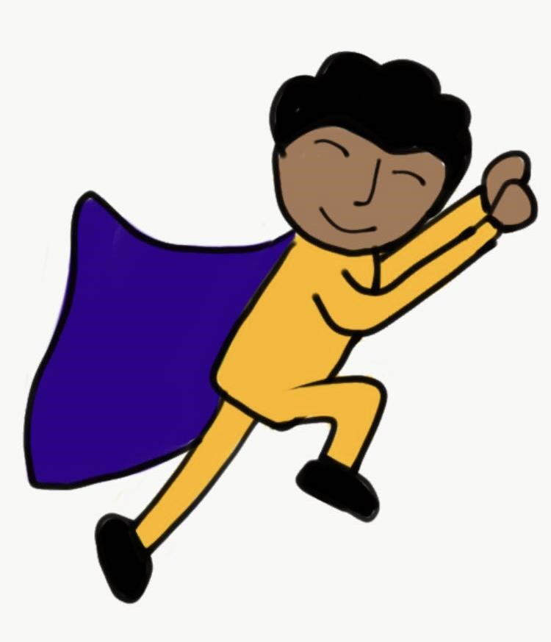

Activity One
Zayn was having a very difficult morning and at first he was trying to keep all his feelings inside. Being a clever and sensible boy, he realized that this was not a good idea and he decided to talk to a safe and trusted person. In the story Zayn chose to talk to Olivia Owl. Draw a picture of the people that you would choose to talk to about your feelings.

Activity Two

Zayn did some calming breaths with Olivia and that helped him to feel better. Here are two different ways of taking some calming breaths. Practice both of them and see which one you like best. If you have a go at your favourite one every day, you’ll get better and better at it.
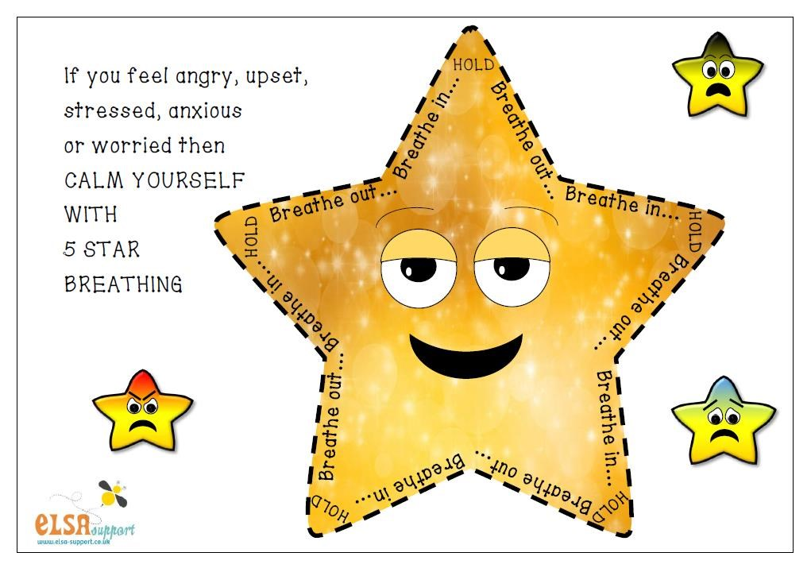
Trace the star with your finger as you breathe in, hold, breathe out and hold.
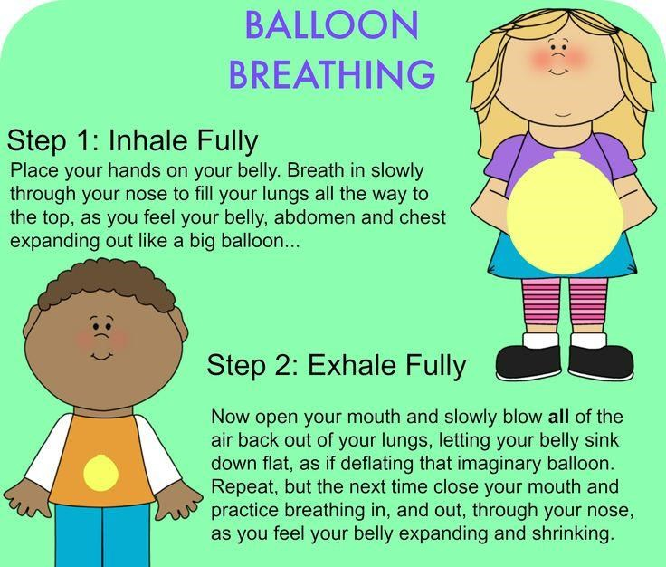

Activity Three

In the story the children had lots of different feelings about going back to school. Some were scared, some were happy, some were angry, some felt like a jelly and some had other feelings. Some children had a couple of feelings and some had lots of feelings. Each person felt their own way.

Think how you are feeling about going back to school. Which feelings are you having? Colour in each shape to show how much of each feeling you have inside you. Some shapes are not labelled as you may be having some feelings that were not mentioned in the story.

Scared Excited Angry

Worried Happy Jelly

Activity Four
Children in the story were looking forward to some things about going back to school but some, like Zayn, were also feeling scared and they had some worries about what might happen. Olivia helped Zayn to feel a little better by reminding him of all the people who were going to take care of him and keep him safe.

Think about the people who are going to look after you, keep you safe and be helping you as you face any challenges. Draw their picture or write their name in each shape.

Activity Five
Zayn began to feel better about facing the challenges of going back to school when he remembered he had coped with lots of challenges before.

Think about the challenges that you have faced in the past even though you felt scared or worried at the start. Remember the ways that you managed, the determination and bravery that you showed. Ask the adult who is with you about the challenges that they remember you facing.

Draw a picture of yourself facing a challenge.

